

InstallShield®

AdminStudio

Setup

Specification

Owner(s) Jigar Desai

Last Updated 8/15/2003 04:26:00 PM

File Name 0000.doc

© 1999 InstallShield Software Corporation. All rights reserved.
THIS IS PRELIMINARY DOCUMENTATION. The information contained in this document represents the current view of InstallShield Software Corporation on the issues discussed as of the date of publication. Because InstallShield must respond to changing market conditions, it should not be interpreted to be a commitment on the part of InstallShield, and InstallShield cannot guarantee the accuracy of any information presented after the date of publication.
This BETA document is for informational purposes only. INSTALLSHIELD MAKES NO WARRANTIES, EXPRESS OR IMPLIED, IN THIS DOCUMENT.
Other product or company names mentioned herein may be the trademarks of their respective owners.
InstallShield Software Corporation • 900 National Parkway • Schaumburg, Illinois 60173-5108

Table of Contents

^{1.0 Abstract} 3
^{2.0 Draco Setup} 3
^{3.0 Requirements} 7
^{4.0 Draco Upgrade} 7
^{5.0 Commad Line} 7
^{6.0 Issues} 8
^{7.0 Revision History} 8

1.0 Abstract
The purpose of this document is to discuss the issues related to the InstallShield AdminStudio Draco setup.

2.0 Draco Setup

The Draco setup project is located in MSI_VSS here: $/InstallShield AdminStudio/Current/Build/Support/AdminStudio.ism. Final build will be on: \\testengineering\builds\AdminStudio\Draco

I UI – Following dialogs will be available in UI sequence.

1. Welcome:
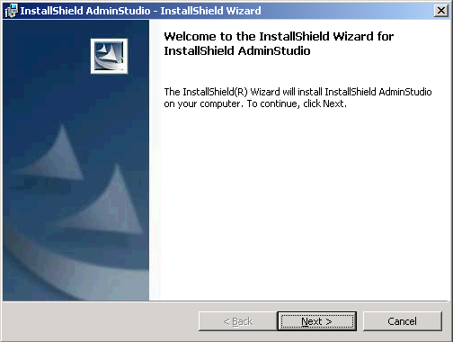

2. License Agreement:
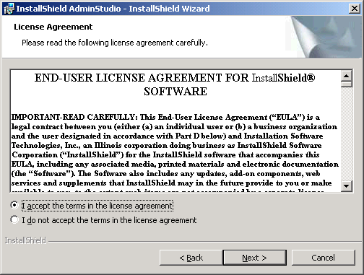

3. Customer Information:
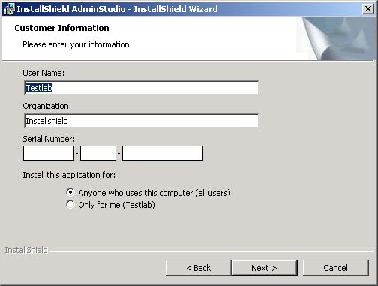

4. Destination Folder:
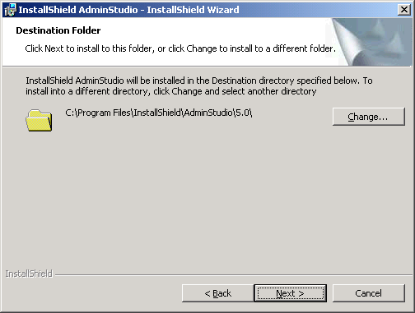

AdminStudio Shared Location:
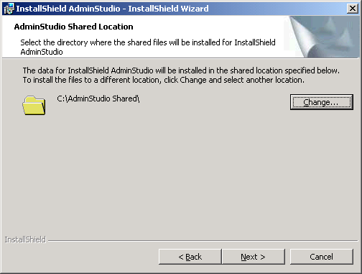

Select Language:
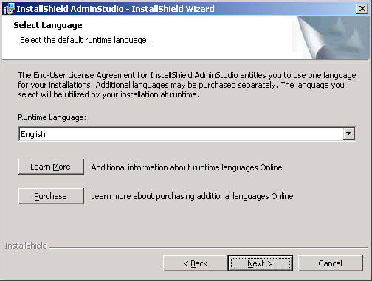

Custom Setup:
*** add dialog ***

Ready to Install the Program:
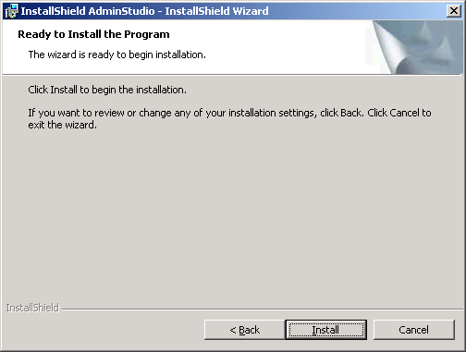

II DevStudio Integration
AdminStudio Draco uses four Developer Merge Modules:
DevStudioCoreMoule.msm – Contains the core files and functionality
DevStudioVSIPModule.msm – contains the VSIP integration components
DeStudioISRedistsModule.msm – contains the InstallShield merge modules
DevStudioThirdpartyRedistModules.msm – contains MS merge modules
DevStudioStandalonebuildCoreModule.msm – DevStudio standalone build
VC_STL.msm
VC_CRT.msm

DevStudioCoreMoule.msm, DeStudioISRedistsModule.msm, DevStudioThirdpartyRedistModules.msm, VC_STL.msm, VC_CRT.msm and DevStudioStandalonebuildCoreModule.msm will be installed by default with Draco release. If .NET is installed on the machine then this feature will be displayed in the Custom setup dialog. If .NET is not installed then this feature will not be displayed in Custom Setup dialog. If user installs any .NET framework after installing AdminStudio Draco then users can go to the Add/Remove Programs and use modify options of AdminStudio to install VSIP.

III Shortcut
There will be only one shortcut. Start | Program menu | AdminStudio
If users want tools shortcut then a property – “ASTOOLS” need to be set on command line. This will install tools shortcut on Start | Program menu | AdminStudio | Tools

IV Product Information
Product Name: InstallShield AdminStudio
INSTALLDIR: [Program Files]InstallShield\AdminStudio
Product Code: {A0025214-795F-4BB1-9406-7A4197749D46}
Version: 6.0 (may change)
Serial Number: (will Change)
PRO Edition - APDADA-0500-3030000007 +23
STD Edition - ASDADA-0500-3030000007 +23
ENT Edition - AEDADA-0500-3030000007 +23

3.0 Requirements
Target machine requirements are
User must logged in with Power User rights
OS must be Win98/ME/NT 4 with SP6 or higher/2000/xp
IE 5.0 or higher

If any of these requirements are not met, the setup should abort with an appropriate error message.

4.0 Draco Upgrade

This section describes the Upgrade scenarios for AdminStudio Draco.
Scenario 1: Install AS 2.0. Install Draco.
Expected Result: Major Upgrade

Scenario 2: Install AS 3.0. Then install AdminStudio Draco.
Expected Result: Major Upgrade

Scenario 3: Install AS 3.01. Then install AdminStudio Draco.
Expected Result: Major Upgrade

Scenario 4: Install AdminStudio 3.5 (include Developer 7.04). Install AdminStudio Draco.
Expected Result: Ask users to manually uninstall AdminStudio 3.5

Scenario 5: Install AdminStudio 3.5 Value Pack 1/Value Pack2. Install AdminStudio Draco.
Expected Result: Major Upgrade

Scenario 6: Install AdminStudio 5.0. Install AdminStudio Draco.
Expected Result: Major Upgrade

Scenario 7: Install AdminStudio 5.0. Install SP1. Install AdminStudio Draco.
Expected Result: Major Upgrade

Scenario 8: Install AdminStudio 5.0. Install VP1. Install AdminStudio Draco.
Expected Result: Ask users to uninstall AdminStudio 5 VP1 manually

Scenario 9: Install Developer 8. Install Draco.
Expected Result: prompt users - i. Co-exist or ii. Remove Dev 8 and then install Draco

Scenario 10: Install DevStudio 9.0. Install AdminStudio Draco.
Expected Result: Install everything from Draco except DevStudio files

Scenario 11: Install Draco Beta Edition. Install AdminStudio Draco full edition.
Expected Result: prompt users to uninstall Beta edition manually

Scenario 12: Install Draco eval Edition. Install AdminStudio Draco full edition.
Expected Result: Major Upgrade

Scenario 13: Install any version of AdminStudio full Edition. Install AdminStudio Draco eval edition.
Expected Result: prompt users to uninstall full edition before installing eval edition

5.0 Command Line

Draco supports all the command line installation options such as
Silent install (/qn, /qb, /qr and /qf),
Advertisement (/ju, /jm) and
Administrative install (/a).

6.0 Issues

7.0 Revision History

Date | Author | Change Reference
08/12/2003 | Jigar Desai | Initial Draft

